
Unitarian Universalist Congregation of South County
March 22, 2026
The first two rows of congregational seating are reserved
for a hearing impaired zone

Sounding the Chime (Air)

Opening Hymn Gather the Spirit Hymn # 347

Welcome Linda Whyte Burrell

Invocation to the Four Corners & Chalice Lighting (Fire)

Opening Words

Covenant In Unison
Love is the spirit of this congregation, and service is its prayer.
This is our great covenant: To dwell together in peace,
To seek the truth in love, And to help one another.

Joys and Concerns (Water & Earth)

Reading

Hymn Earth was Given as a Garden Hymn # 207

Sermon Seasons, Cycles and Changes Linda Whyte Burrell

Offering

Offertory Coming Home by Chris Johnson

Hymn For All That is Our Life Hymn # 128

Closing Words

Announcements

Releasing the Four Corners & Extinguishing the Chalice
We extinguish this chalice, but not its light.
That we take with us out into the world,
sharing it with those we encounter on our journey.
Closing Song
Carry the flame of peace and love until we meet again. (3x)

Newcomers, please fill out a yellow welcome card,
which you can find in the back of the gray hymnal, and put it in with the offering or give it to one of the greeters.
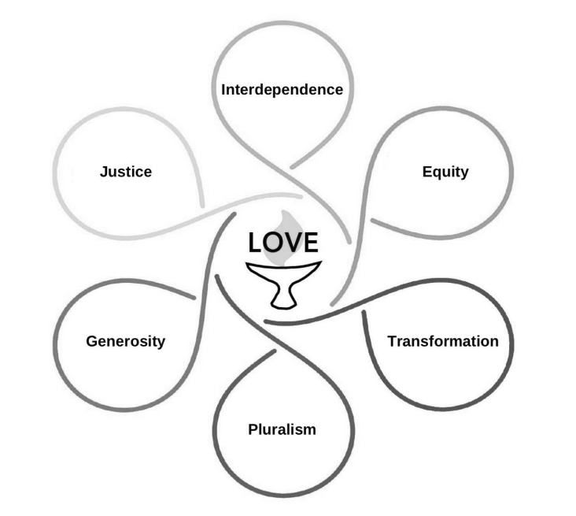

Rev. Denis Letourneau Paul, Minister
Ami Pienknagura, Music Director
Lee Cowan, Director of Faith Exploration
Sara Kaplow, Congregational Administrator; Amenata L. Botus, Congregational Bookkeeper


Rev. Denis’s Office hours Tuesdays & Thursdays 10-4
Next furlough week: April 13 to April 20.

Plate Donations gratefully accepted
via Square App using this QR code

