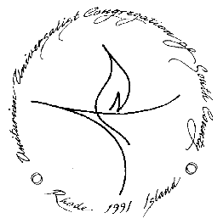
Unitarian Universalist Congregation of South County
Order of Service October 2, 2022
Sounding the Chime

Welcome and Announcements Rev. Denis Letourneau Paul

Opening Hymn The Fire of Commitment Hymn #1028

Chalice Lighting Linda Whyte Burrell
“The Chalice” by Rev. Dr. Charles Rhind Joy

Opening Words

Repeating the Covenant Together
Love is the spirit of this congregation, and service is its prayer.
This is our great covenant: To dwell together in peace,
To seek the truth in love, and to help one another.

Joys and Concerns

Offering

Offertory Seize the Day from "Newsies" by Alan Menken

Responsive Reading “Gloria!” by Rev. Barbara J. Pescan #534

Hymn Jazz Alleluia #1050

Homily “Ordinary Tenacity” Rev. Denis Letourneau Paul

Hymn Wonders Still the World Shall Witness #139

Closing Words Hawai’ian Blessing

Extinguishing the Chalice
We extinguish this chalice, but not its light.
That we take with us out into the world,
sharing it with those we encounter on our journey.

Closing Song
Carry the flame of peace and love until we meet again.(3x)

